**ASSIGNMENT – 2**

NAME : PRANAVA KUMAR REG NO : 727619BIT082

# 1) SALES BY CUSTOMER

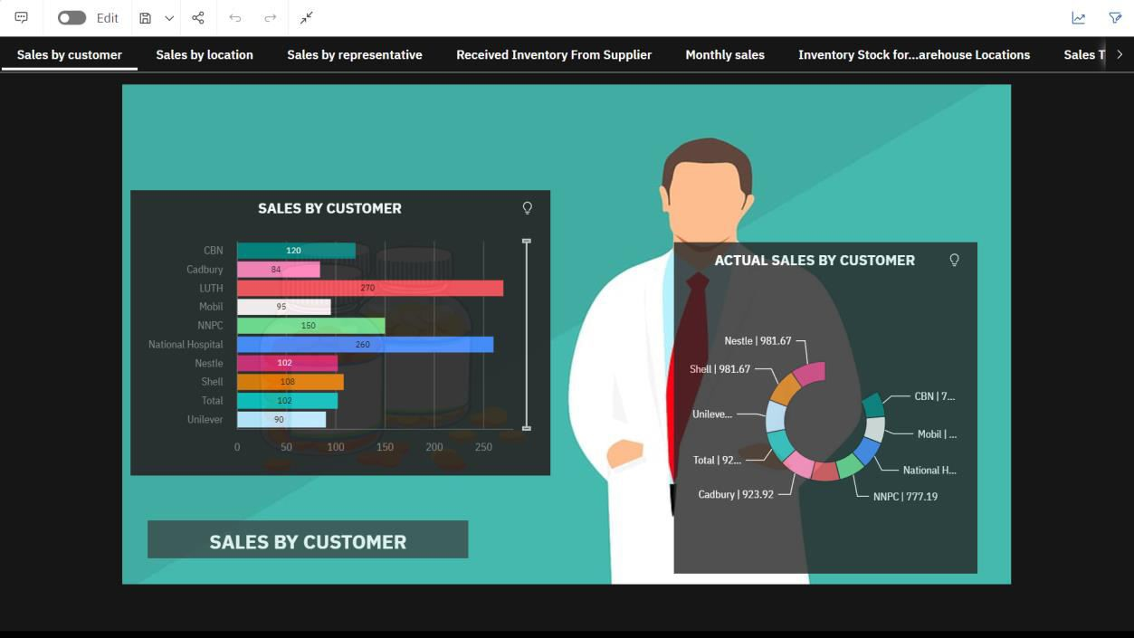

## 2) SALES BY LOCATION

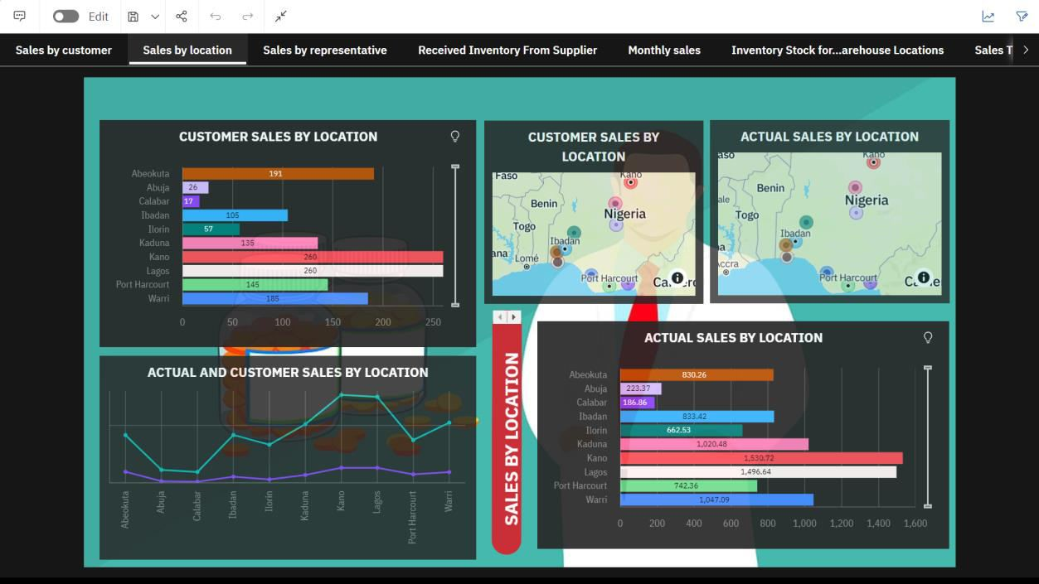

## 3) SALES BY REPRESENTATIVE

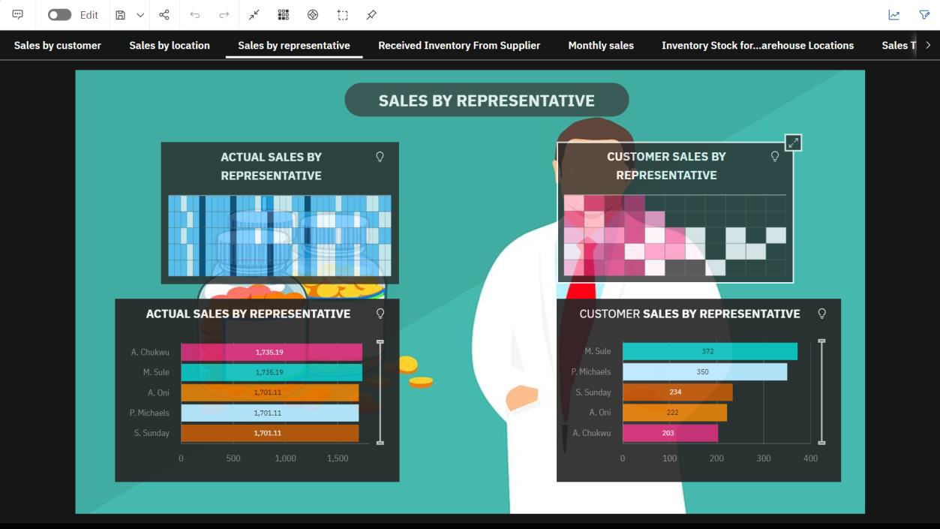

## 4) RECEIVED INVENTORY FROM SUPPLIER

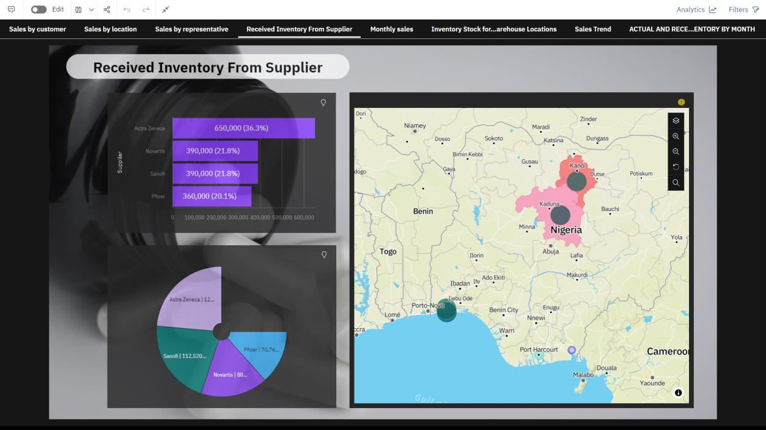

## 5) MONTHLY SALES

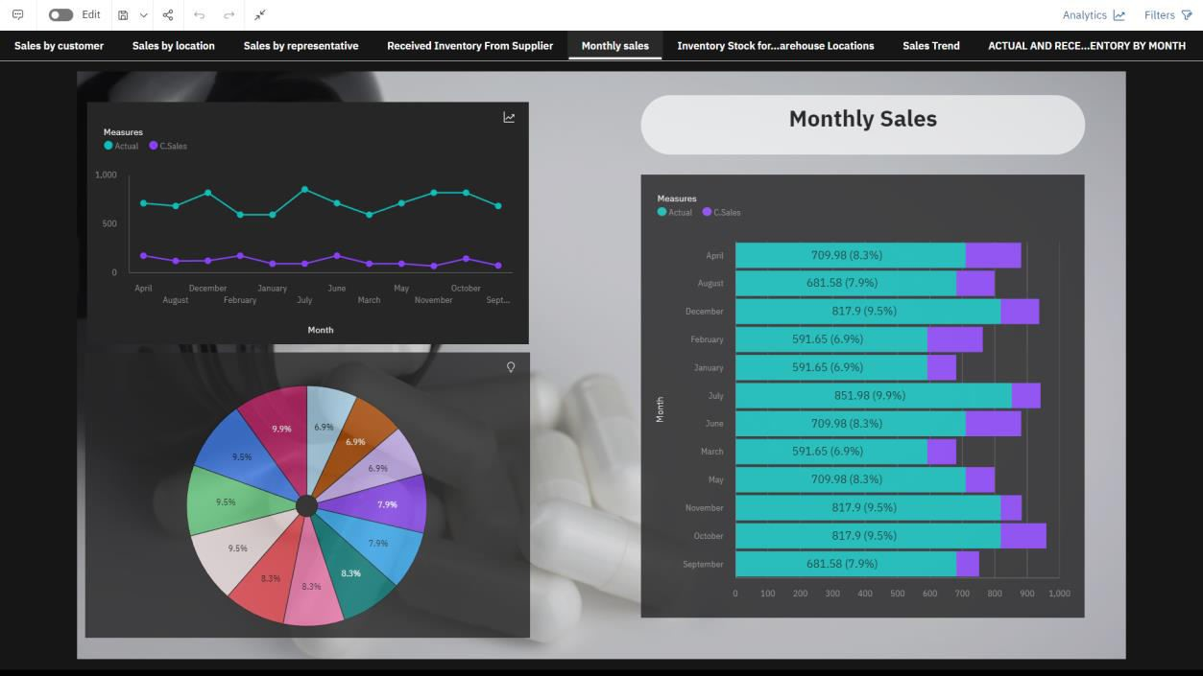

## 6) INVENTORY STOCK FOR WAREHOUSE LOCATION

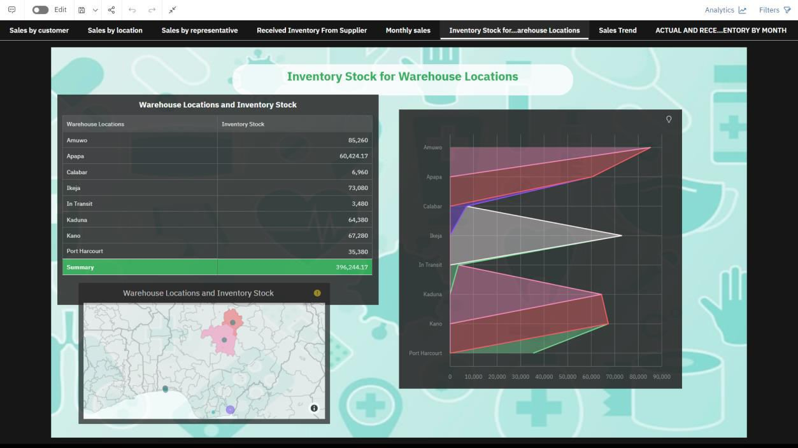

## 7) SALES TREND

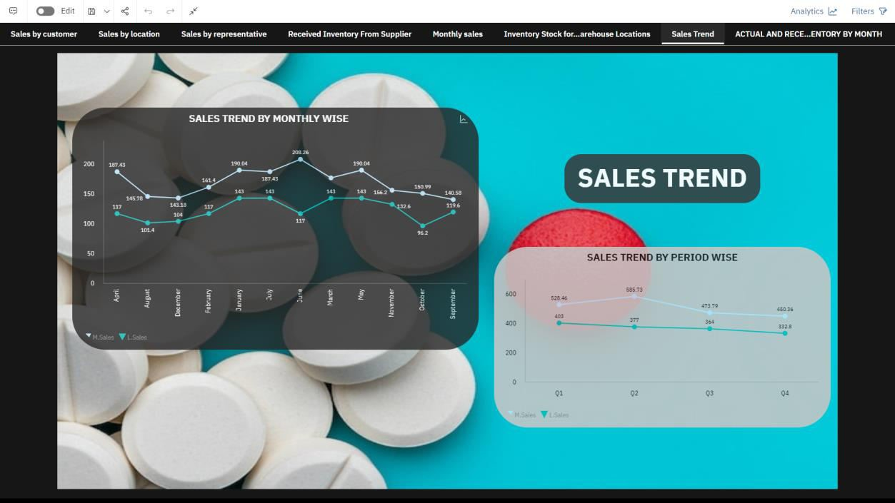

## 8) ACTUAL AND RECEIVED INVENTORY BY MONTH

